BIA-810
Final Project
May 12th, 2025

Analyzing Market Dynamics and Revitalizing Brand Strategy for Market Cannibalization of an Injectable Anesthesia Drug

Problem Statement:

The anesthesia drug market is a segment of the pharmaceutical industry that focuses on the development, production, and distribution of medications used to induce and maintain anesthesia during medical procedures and surgeries. The market for anesthesia drugs encompasses a wide range of pharmaceutical products, including general anesthetics, local anesthetics, and adjunctive drugs that support the anesthesia process. The demand for these drugs is closely tied to the healthcare industry, as the number of surgical procedures, including both routine and complex surgeries, continues to grow worldwide. Factors such as an aging population, increased healthcare access, and advancements in medical technology contribute to the expansion of the anesthesia drug market.

You are a Healthcare Commercial Analytics leader working for anesthesia drugs portfolio at a big pharma company. As an analytics leader, understanding market dynamics and making evidence-based decisions are crucial for the success of the business. Your company has a market leading brand (Product 1) in the anesthesia portfolio. Your company also has recently launched a variant of the same brand (Product 2) in the market which is supposed to cannibalize your leading brand. (Market cannibalization is a loss in sales caused by a company's introduction of a new product that displaces one of its own older products in the market. The cannibalization of existing products need not necessarily lead to an increase in the company's overall market share, but at least the sales growth for the new product should be at the expense of the drop in sales of the old product.)

However, the expected cannibalization is not happening in the market. It appears that instead of your new product capturing the dropping sales of your old product, one of your competitors (Product 3) is rapidly gaining market share, leaving your new product (Product 2) to lose its expected market share.

Your tasks are:
- Perform data preparations using the datasets provided to have one analysis-ready dataset.
- Analyze the provided Medicare CCLF claims data using the Key Business Questions provided below, and come up with strong data-driven, actionable business recommendations to gain market share for Product 2
- Compile the above analysis and recommendations into a PowerPoint presentation.
- Present your findings to a panel of judges using the presentation.

Market Definitions:
Market: Injectable Anesthesia Market

Market Basket:
Product | Procedure Code | Generic Name | Product Description
Product 1  (Market Leader - Your old Brand) | J1885 | ketorolac tromethamine | Ketorolac is used for the short-term treatment of moderate to severe pain in adults. It is usually used before or after medical procedures or after surgery
Product 2  (Variant Brand - Your new Brand) | J2250 | midazolam hydrochloride | Intravenously injected for induction of general anesthesia
Product 3 (Main Competitor Brand) | J3010 | fentanyl citrate | For analgesic action of short duration during the anesthetic periods, premedication, induction, and maintenance, and in the immediate postoperative period (recovery room) as the need arises
Product 4  (Alternative Competitor Brand) | J2704 | propofol | Propofol injection is used to help you relax or sleep before and during surgery or other medical procedures. This medicine is an anesthetic and a sedative

Product Performance:
- Leader Brand (Product 1): The brand with the largest market share is experiencing a consistent decline.
- Variant Brand (Product 2): The newest brand that is slowly losing market share.
- Main Competitor Brand (Product 3): A competitor brand that is rapidly gaining the market share of Product 1, which Product 2 is supposed to absorb.
- Alternative Competitor Brand (Product 4): Another competitor brand in the market. Though Product 3 is the primary competitor brand, this product absorbing the market share is also a threat for your brands. So, consider Product 4 as a competitor brand as well.

Project Structure:
Market Analysis: Students should start by performing a comprehensive analysis of market dynamics, including market share trends, growth rates, and external factors impacting the market.

Competitive Landscape: Understand the competitive landscape by comparing the performance of the four brands.

Identifying Key Drivers: Identify the key drivers behind the declining market share of the variant brand, the decline of the market leader brand, and the growth of the competitor brand.

Recommendations: Based on the analysis, students should propose data-driven recommendations and solutions to address the current market challenges. Possible areas of business recommendations/observations can include:

- Marketing and Promotion (For Key Business Questions 1, 2 and 3): Analyze marketing and promotional strategies, identifying areas for improvement. Investigate the effectiveness of targeting specific customer (HCPs and Patients) segments, on-field salesforce performance, NPP channels, samples, speaker programs, etc.
- Market Access (For Key Business Question 4): Explore opportunities for expanding into new markets or segments, winning new formularies, new indications approval, Line of Therapy approval, copay/payer assistance.
- Product Strategy (For Key Business Question 4): Evaluate the product portfolio including features, form, mode of administration, site of care, dosage, distribution, pricing, product innovation, forecasting, manufacturing and supply chain, and legal and medical affairs.

Datasets:
- Medicare Claims Data (compressed csv files in 5 parts)
- HCP Demographics Data - HCP_demographics_data.csv
- Patient Demographics Data - Patient_demographics_data.csv
- Zip to Territory Mapping Data - Zip_to_Territory_Mapping.csv
- Diagnosis Code Mapping Data - Diagnosis_Code_Mapping.csv

Data Prep for the Analytics-Ready Dataset:
Medicare Claims Data:
- The Medicare Claims data has about 1 million records at Claim ID and Line-item level of granularity.
- You would be receiving this dataset in 5 parts in the form of compressed csv files. Unzip the csv files and merge them together to create the combined raw claims data frame of 1 million records.
- Please find the description of the important data fields from the raw claims data below:
  - 'cur_clm_uniq_id' : Claim ID
  - 'bene_mbi_id' : Patient ID
  - 'fac_prvdr_npi_num' : HCP ID (in standard 10-digit NPI ID format)
  - 'clm_from_dt' : Claim Date
  - 'clm_dgns_cd' : Diagnosis Code
  - 'clm_line_hcpcs_cd' : Procedure Code
- Filter for all the claims belonging to the Market brands (Procedure Codes) - J1885, J2250, J2704, J3010 to get the required analytics ready data. Please note that you need to filter all the records of the claims that belong to these brands and not just the records that have these Procedure codes. (Hint: Record count of the filtered data: 28,368)
- Please use the 'clm_from_dt' as the Claim Date for all the analyses.
- All the 'clm_dgns_cd', i.e., diagnosis codes, are ICD-10 codes. The initial alphabet of these codes (e.g., for the diagnosis code ‘I10’ – the initial is ‘I’) are required to map the specialty of the diagnosis using the Diagnosis Code Mapping Data.

HCP Demographics Data:
- Join the required data fields to the filtered claims data using the HCP ID as the key.

Patient Demographics Data:
- Join the required data fields to the filtered claims data using the Patient ID as the key.

Zip to Territory Mapping Data:
- Join the required data fields to the filtered claims data using the HCP zip code mapped from the HCP Demographics Data as the key.
- Please note that these zip codes, territories, and regions correspond to HCPs and not the patients.
- Also, note that while making a join using zip code as a key, make sure both the primary and the secondary keys have the same format. The zip codes should be in the standard 5-digit format. A few zip codes with leading zeroes, say, for example, ‘01104’, might get converted into ‘1104’ as you import and process data from the raw csv files.
- Please note that a few Zip codes and their corresponding Territory cities may not exactly match the real-life zip codes and you can ignore them and simply use this file to map the Territories.

Diagnosis Code Mapping Data:
- Map the diagnosis specialty to the filtered claims data using the initial alphabet of the diagnosis code as the key.
- Please note that these ICD-10 codes are aggregated by the specialty of the disease being diagnosed.
- This is to identify the nature of the disease (e.g., cardiovascular, neurological), and there are ICD-10 codes for all the possible disease and disorders which are identified by a series of alphanumeric codes and aggregated by their initial alphabet to broadly classify the disease specialty.

Note:
- You are free to use any tool (e.g., Python, Excel, or anything of your choice) to prepare the dataset and produce the charts and visualizations. However, you must submit either a Jupyter notebook or Excel spreadsheet that shows all the data prep, code, and charts.
- Please use the PPT deck template provided to populate your slides.
Analytics Ready Data
Key Business Questions:
1. Market Dynamics and Competitive Landscape Assessment:
Perform a comprehensive analysis of the injectable anesthesia market for the years 2016 to 2018. Identify and explain the trends in market share, growth rates, and other key indicators for Products 1, 2, 3, and 4. How have these trends evolved over time, and what insights can be drawn from them? Compare and contrast the performance of Products 1, 2, 3, and 4 in the market. What sets Product 3 apart as a competitor that is rapidly gaining market share while Products 1 and 2 are struggling?
Hints:
  - Calculate and analyze the share of claims, patients and the HCPs using the HCPCS/CPT codes of these 4 products.
    - Expected outputs:
      - A 100% stacked bar graph showing claims percentage of each product per year, where one bar represents one year.
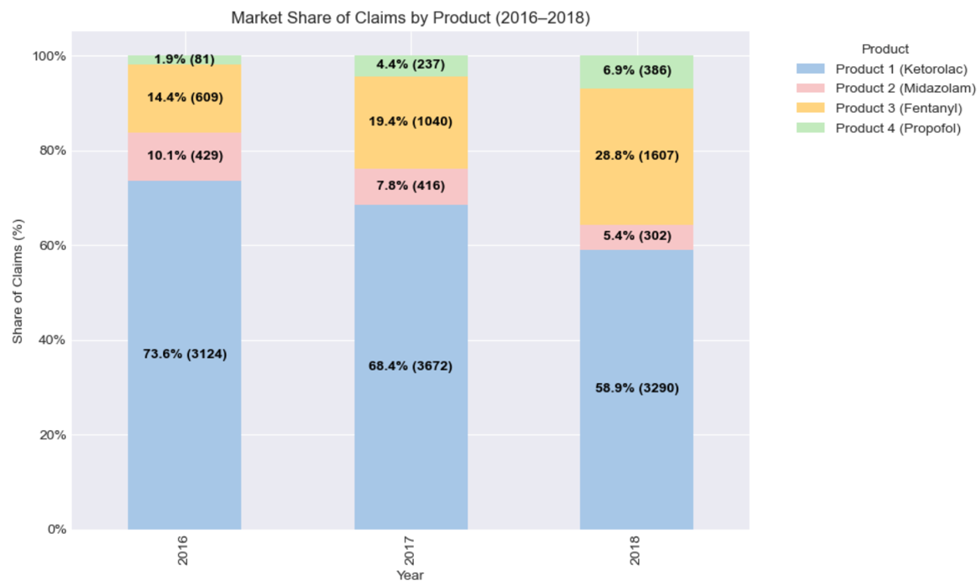
      - A 100% stacked bar graph showing the number of patients of each product per year, where one bar represents one year.
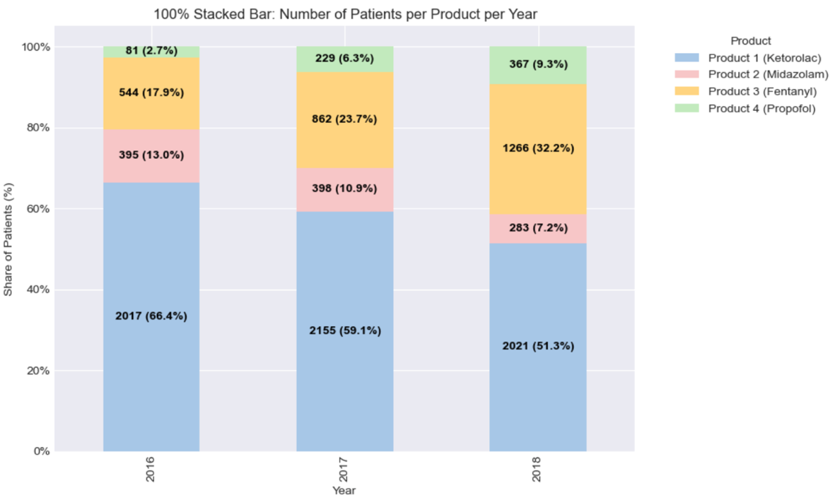
      - A 100% stacked bar graph showing the number of HCPs (I.e., writers) writing claims for each product per year, where one bar represents one year.
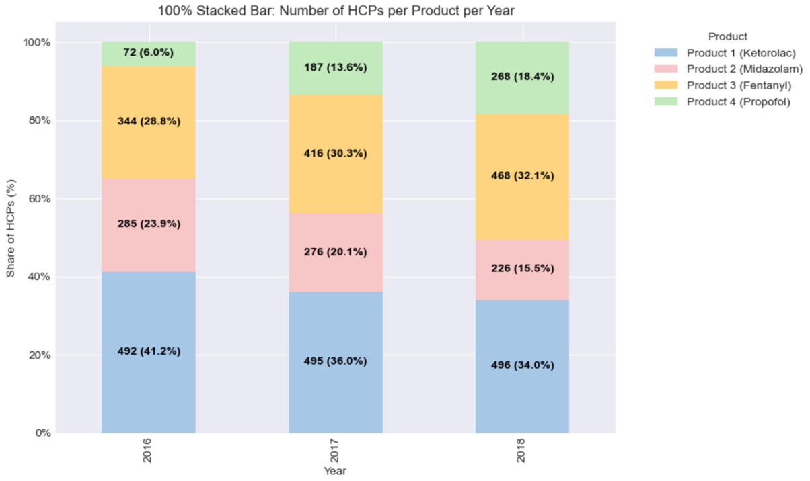
      - What do you observe from the charts above? What would be your actionable recommendations based on your observations?
        - We can see that even though the number of claims, patients, and HCPs has increased from 2016 to 2017, the market share in these three areas still declined for Product 1.
        - The number of claims and patients for Product 1 declined from 2017 to 2018, along with the market share.
        - From 2017 to 2018, the number of HCPs for Product 1 only increased by 1, while the number of patients decreased by more than 100. This indicates that Product 1 might not be targeting the right HCPs. We need to see the average claims and patients per HCP per year to help determine what the problem is.
        - Product 2 is expected to cannibalize Product 1, but both products are losing share simultaneously while Product 3 captures the majority of the losing market. This means that the company’s customers were not moving from Product 1 to Product 2 as intended; instead, they were leaving the portfolio altogether. The company needs to change its portfolio strategy.

  - Calculate and analyze the number of claims per HCP (aka writer) and the number of patients per HCP for each product.
    - Expected outputs:
      - A line graph showing the number of claims per writer per year, where one line represents one product, and one set of vertical data points are for one year.
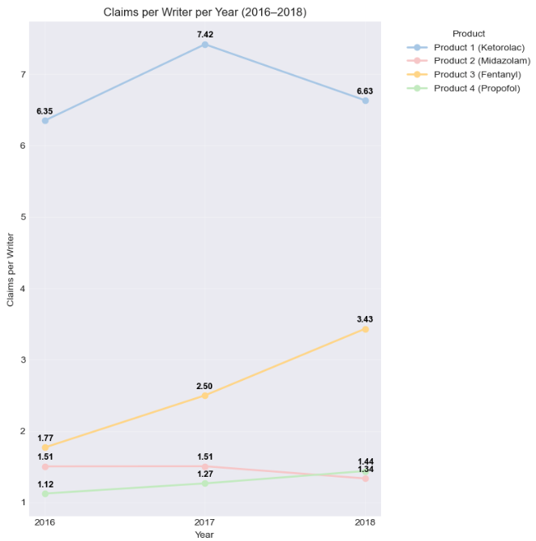
      - A line graph showing the number of patients per writer per year, where one line represents one product, and one set of vertical data points are for one year.
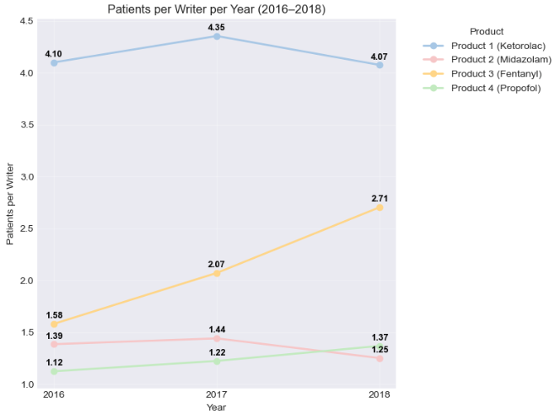
      - What do you observe from the charts above? What would be your actionable recommendations based on your observations?
        - We can see from the two line graphs that Product 1 has the highest number of claims and patients per HCP per year. There is an increase from 2016 to 2017 and a decrease from 2017 to 2018. Same trend for Product 2.
        - The two competitors, Product 3 & 4, are making a steady increase each year.
        - At first, the assumption was that the company might not be targeting the right HCPs. But in these two line graphs, even though there is a decrease from 2017 to 2018, the average number of claims and patients per HCP per year is still higher than the rest.
        - Product 3 is quickly taking over HCPs with a high volume of claims and patients, while Products 1 & 2 are losing them.
        - The best thing to do next is to look more into the HCPs and claims data. We can first do some analysis to see which territory we are losing the most claims from.
  - Find the top 5 territories with the most drop in claims volume from year 2017 to 2018 for the variant brand and compare it with that of the competitor brand (Product 3 – J3010).
    - Find the territory-level claims volume per product per year.
    - Calculate the year-over-year change % for the variant brand between 2017 and 2018.
    - Sort the territories from smallest to largest value from above.
    - Take the top 5 territories with the smallest value for year-over-year change % (I.e., biggest drop in claims volume from 2017 - 2018) and extract the claims count for the variant brand and the competitor brand for each year from 2016 – 2018 for these 5 Territories.
    - Expected outputs:
      - A clustered bar chart showing the number of claims from each of these 5 territories for each year from 2016 – 2018 for the variant brand, where one bar is for one Territory within each year and the bars for one year are clustered together.
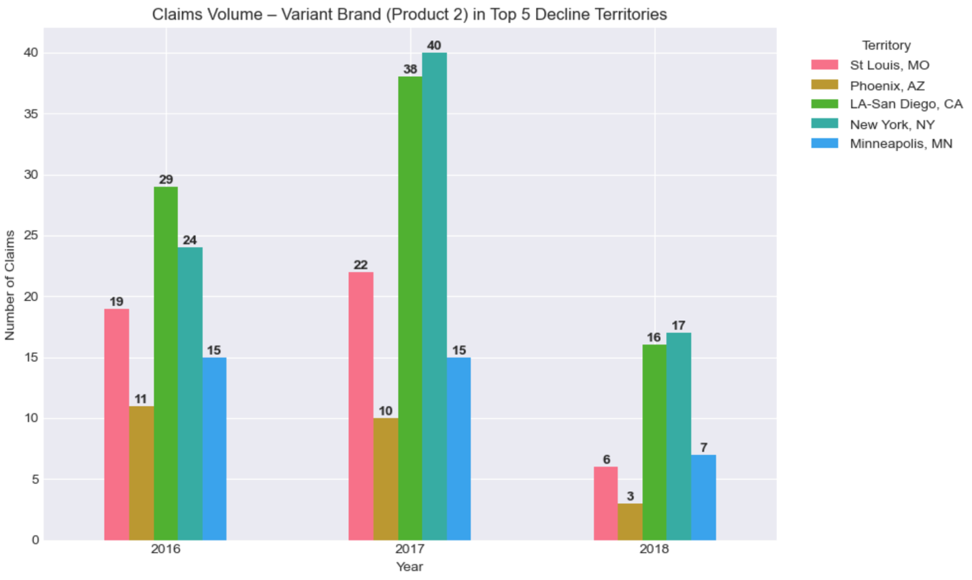
      - A clustered bar chart showing the number of claims from each of these 5 territories for each year from 2016 – 2018 for the main competitor brand (J3010), where one bar is for one Territory within each year and the bars for one year are clustered together.
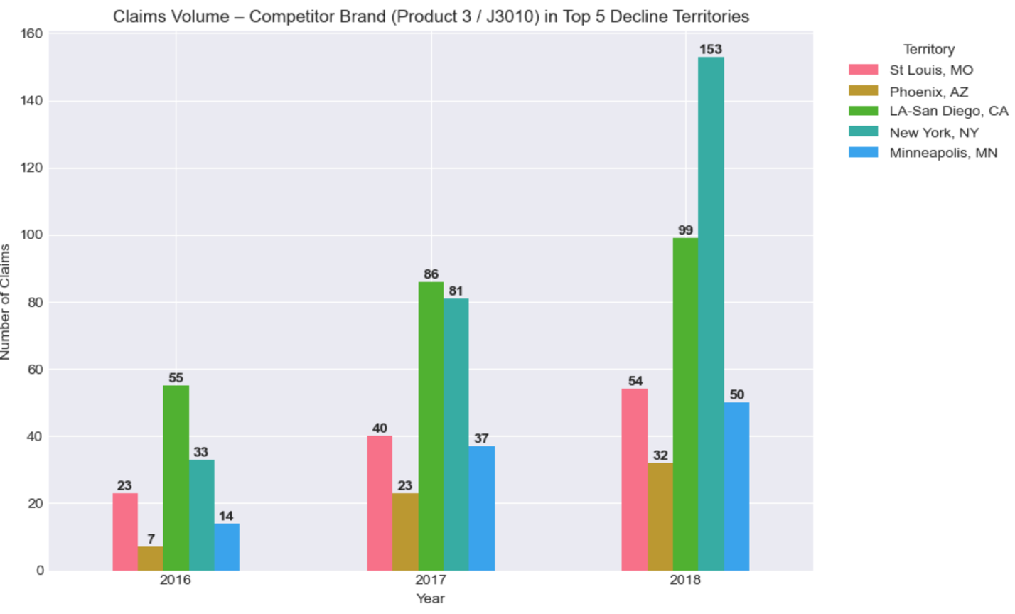
      - These charts should compare and contrast the relative growth of J3010 compared to the variant brand in these 5 territories for each year, especially between 2017 and 2018.
      - Strategic recommendations can be different for highly populated Territories and the less populated ones, as they can follow the similar claim volume trends, but the HCP and patient populations are totally different between them. Think about the solutions proposed for Mid Terms.
      - What do you observe from the charts above? What would be your actionable recommendations based on your observations?
        - Product 2 (Variant Brand) is showing a sharp decline across all 5 territories from 2017 to 2018, while the competitor Product 3 is showing a strong, consistent growth in every territory. This indicates an active replacement behavior where the competitor is becoming the alternative instead of the variant brand.
        - For high-population areas such as New York and LA-San Diego, Product 2 peaked in 2017 but dropped sharply in 2018, while competitor brand Product 3 has large absolute claim increases year over year, especially New York area.

2. Identifying the trends of the Key Market Drivers of the Injectable Anesthesia Market:
You got to know from the Primary market research team that the Patient Age, Specialty of the patient diagnosis, HCP Specialty and New prescriber growth are the key Market Drivers of the Injectable anesthetics. Investigate these metrics and their trends. How could you leverage the trends of these key market drivers to increase your market share for Product 2? How could these trends relate to the competitor brand’s growth (Product 3) and your Variant brand’s decline (Product 2)?
Hints:
  - Identify the medical fields or the specialties of the diagnosed patients using the diagnosis codes and the Specialties of the HCPs prescribing these drugs using the specialty group of the HCPs within the injectable anesthesia market (all 4 brands together) for years 2016-2018.
    - Expected outputs:
      - A pie chart showing the percentage of claims that each diagnosis specialty contributes. Extract the diagnosis code initial and map the diagnosis specialty using the diagnosis code mapping dataset. Show only the top 5 diagnosis specialties.
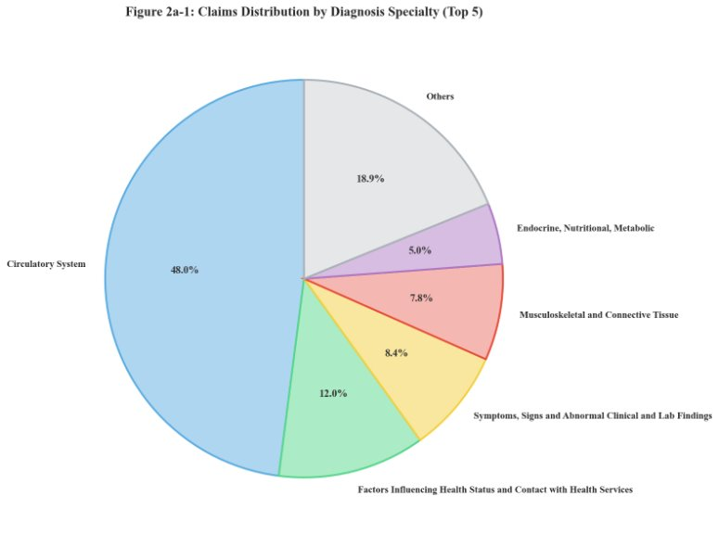
      - A horizontal line graph showing # of writers from each HCP specialty group mapped using the HCP demographics dataset.
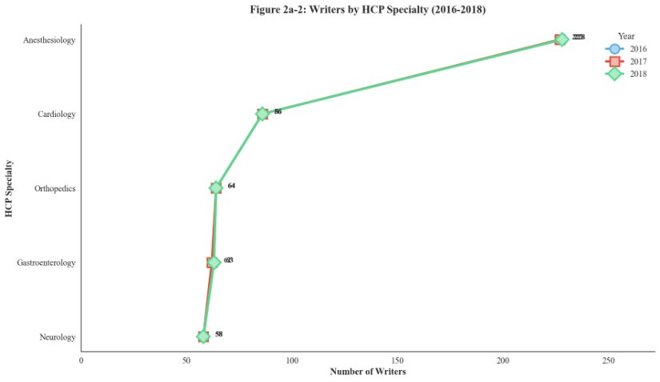
      - What do you observe from the charts above? What would be your actionable recommendations based on your observations?
Observation: The diagnosis specialty analysis reveals that circulatory system conditions account for nearly half (48.0%) of all claims in the injectable anesthesia market, followed by factors influencing health status (12.0%) and symptoms/signs categories (8.4%). This distribution aligns with the typical patient population requiring anesthesia services, predominantly cardiovascular surgery and related procedures. Regarding HCP specialties, anesthesiologists dominate the prescriber base with 228 writers, significantly exceeding other specialties including cardiology (86), orthopedics (64), gastroenterology (63), and neurology (58). The HCP specialty distribution remained stable across all three years, indicating a mature prescriber base with limited specialty expansion.

Recommendation: Marketing efforts should prioritize anesthesiologists as the primary target audience given their dominant prescribing volume. However, the stable writer count across specialties suggests market saturation among traditional prescribers. To drive growth, explore expansion into adjacent specialties such as emergency medicine and interventional radiology where procedural sedation demand exists. For circulatory system patients, develop clinical messaging emphasizing Product 2 safety profile in cardiovascular procedures, potentially differentiating from opioid-based alternatives like Product 3.
  - Find the trend of patient and claim distribution based on patient age within the injectable anesthesia market (all 4 brands together) for years 2016-2018.
    - Expected outputs:
      - A bar graph showing # patients from each age group using the following age buckets:
        - 18-30, 31-40, 41-50, 51-60, 61-70, 71-80, 81+
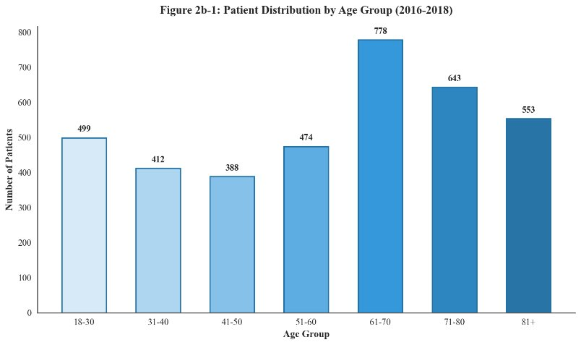
      - A bar graph showing percentage of claims from all 4 brands using the same age buckets as above.
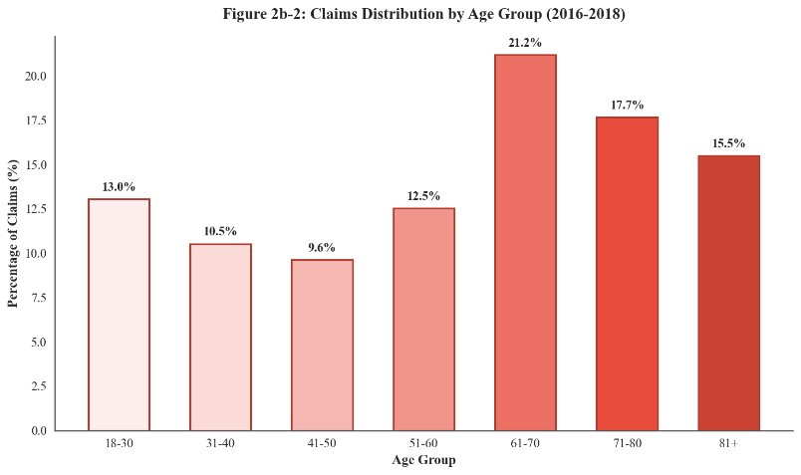
      - What do you observe from the charts above? What would be your actionable recommendations based on your observations?
Observation: The patient age distribution demonstrates a clear concentration in older age groups, with patients aged 61 and above accounting for approximately 54% of all claims. The 61-70 age group represents the largest segment at 21.2% of claims, followed by 71-80 (17.7%) and 81+ (15.5%). This distribution reflects the Medicare population characteristics inherent in the dataset and aligns with higher surgical intervention rates among elderly patients. The younger age segments (18-50) collectively represent only 33% of claims, indicating limited market penetration in younger patient populations requiring anesthesia services.
Recommendation: Given the elderly patient concentration, Product 2 marketing should emphasize safety profiles relevant to geriatric populations, including reduced respiratory depression risk compared to opioid alternatives and faster recovery times. Clinical messaging should address polypharmacy considerations common in elderly patients. Additionally, explore opportunities in ambulatory surgery centers and outpatient facilities that increasingly serve the 61-80 age demographic for elective procedures, where Product 2 short-acting properties may offer operational advantages.
  - New and continuing writer (HCP) trends of the four brands. Identify the new HCPs writing for each of the brands based on the claim year from 2016 – 2018 and identify the continuing writers for each of the brands based on the claim year for 2017 and 2018.
    - Expected outputs:
      - A clustered bar chart showing # new writers for each brand from each year, where one bar is for one brand, and the bars are grouped into each year from 2016 – 2018. New Writer refers to the HCPs who prescribed the brand for the first time between 2018 and 2018.
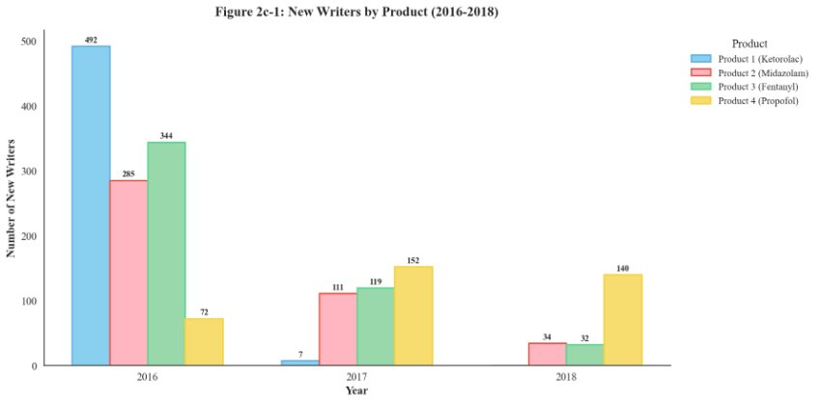
      - A line chart showing # of continuing writers for each brand for each year between 2017 and 2018 where each line should belong to each brand. The continuing writers are HCPs who continued to write the brand after the first prescription in the following years.
Continuing Writers = Total Writers – New Writers. So, find the Total writers in each year and each brand and subtract the corresponding new writers to get the continuing writer count.
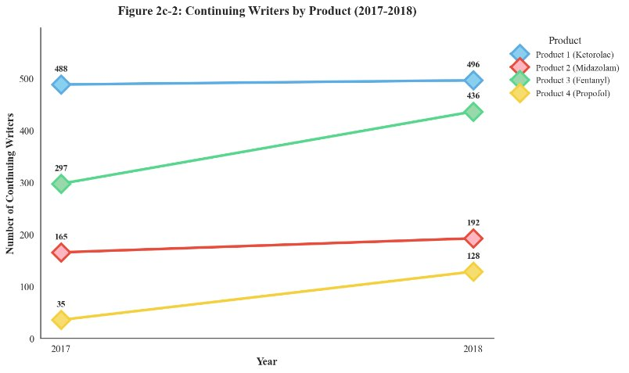
      - What do you observe from the charts above? What would be your actionable recommendations based on your observations?
Observation: The new writer acquisition data reveals a critical challenge for Product 2. While Product 1 shows near-zero new writer acquisition (7 in 2017, 0 in 2018) indicating market maturity, Product 2 new writer numbers declined from 285 in 2016 to only 34 in 2018. Product 3 maintained relatively stable new writer acquisition (344 to 32 over the period), and Product 4 demonstrated exceptional growth in new prescribers (72 to 140). Continuing writer analysis shows Product 3 with the strongest retention trajectory, increasing from 297 to 436 continuing writers, while Product 2 showed modest improvement from 165 to 192. Product 4 exhibited remarkable continuing writer growth from 35 to 128, indicating strong prescriber loyalty once adopted.
Recommendation: The declining new writer acquisition for Product 2 requires immediate attention. Implement a new prescriber incentive program targeting HCPs who currently prescribe Product 1 or Product 3 but have not adopted Product 2. Focus on trial generation through expanded sampling programs and starter kits. For continuing writers, develop a loyalty program with enhanced support services to improve retention and increase prescription volume. Analyze the Product 4 success factors in new writer acquisition and continuing writer retention to identify transferable strategies for Product 2.
Note: For all the questions and the charts created above, just come up with 1 observation and 1-2 actionable recommendation(s) at most for each chart which you feel should be the most important one to increase the market share of the Variant brand.
3. Strategies to stop the market share erosion and gain traction in the market for the Variant Brand:
You may convince your leadership to increase the budget and/or labor resources to gain market leadership. The analyses you have done so far should support the recommendations. What are the key business areas or metrics that require attention based on the metrics analyzed so far? Based on your observations, what are the strategic recommendations you would offer to the on-field sales force and promotional strategies. How can improvements be made to target specific customer segments, optimize the sales force, and enhance non-personal promotions? Your solution should include actionable steps to stop the eroding market share of the Variant Brand immediately as a priority.
Hints:
- Highlight the most important observations in the market from the analyses done so far.
- Provide actionable recommendations based on these important observations and it may be around the specialties of the HCPs and/or the patients being diagnosed, HCP writing volume and trends, and sales performance of specific geographical areas (Territories).
- In this section, you need to comprehend all the important actionable recommendations from the first two sections and be able to defend your recommendations with analytics and reasoning within the scope of this course syllabus.
- Make sure your recommendations are backed by only the analytics brought out by the visualizations in the previous two sections. Anything outside the scope of these questions above can be brought out in the next section below.

4. Data Exploration Opportunities (Qualitative):
What are the analyses you would pursue out of the scope of the given Medicare claims data? Do you have any concerns with the data? If so, why, and what actionable steps would you take to resolve this while not losing sight of the primary goal of arresting the losing market erosion? What data gaps did you find in the given data and what other datasets can help you fill this and provide the data summaries you want for this case?
Hints:
- Think about the DDD, NPA/NSP, Exponent/Exponent, Calls and NPP Promotion response data, claims data and Channel Dynamics datasets you learnt from this course.
- Also, think about the other data items you typically get from the claims data which you do not find in the given datasets. Explain the most important data items you might have used in the context of this case which were missing in the given datasets to provide further analytics and the recommendations based on it.
- Please note that there could be many such data items and provide only 4-6 important analytics you might have pursued and the recommendations you might have brought up to increase the variant brand’s market share. These points can be qualitative and need not do any special research. Please make it short and concise with what you studied in this course.

Deliverables:
The deliverables should include:
  - A PowerPoint presentation deck (.pptx) with the summaries of the analytics and the recommendations using the template provided.
  - A Jupyter workbook (.html and .ipynb format) and/or Excel spreadsheet (.xlsx) with the codes used for data prep, analytics, and calculations, pivot tables and visualizations (if required). The file must be readable without any additional processing or any special applications.

Assessment Criteria:
- The quality and depth of the analysis performed on the provided datasets.
- The clarity, structure and quality of the charts and visualizations.
- The critical thinking, creativity, and effectiveness of the proposed recommendations.
- Clear and confident communication of thoughts during the project presentation within the bounds of the given time slot.

